
This document aims to provide a high-level overview of your AWS environment and confirm expectations for deliverables following a Security and Health Assessment (SHA). Questions may be covered during initial scoping calls, and as such, the consultant may pre-fill some details.
AWS Security & Health Assessment
Scoping Questionnaire

Initial Questions
Priorities & Challenges
Question | Answer
Are there known security issues or vulnerabilities that need immediate attention?
What are the top three pain points or challenges you face in securing your AWS environment?
Are there specific deadlines or milestones for the assessment's findings and recommendations?

Security Posture & Practices
Question | Answer
Are there any specific compliance frameworks or standards (e.g., ISO 27001, PCI DSS, GDPR) that the environment must adhere to?
What is your current process for managing and applying security patches across AWS resources?
Do you have a defined Incident Response Plan (IRP) for cloud environments?
Do you currently use AWS Security Hub, GuardDuty, or other AWS-native security tools?

General Technical
Question | Answer
How many AWS accounts are in scope?
Do the accounts form part or all of an AWS Organization?
How is access to the AWS accounts managed?
Who is responsible for supporting/maintaining your AWS environments?
Please list, approximately, the services/resource types in scope for the assessment (if known)
Of the listed resources above, please list any that should be prioritized for assessment/remediation
How are new/existing resources dedployed/managed? | [ Console / CLI / IaC / Other ]

Additional context
Question | Answer
Are there any integrations with non-AWS resources or services that impact security?
Do you expect any major changes or scaling in the environment during the assessment period?

How to estimate resource quantity
Due to limitations in how tags are applied and retrieved, it is impossible to achieve sufficiently accurate results programmatically. Therefore, you will need to complete the steps in the AWS console.
The following steps will need to be repeated in each AWS account in scope for the SHA.

- Log into the required AWS account and navigate to the Tag Editor console
- For the Regions dropdown, select All regions
- For the resource type dropdown, select All supported resource types
- Leave all tag fields empty
Your search options should look like this:
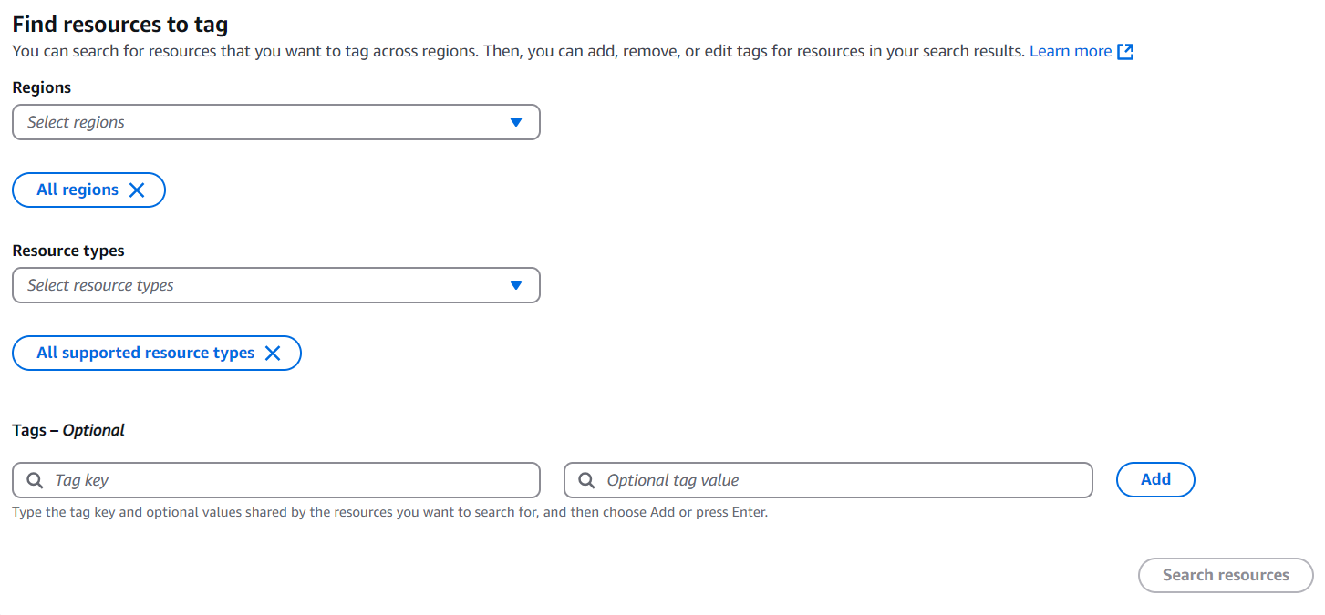
- Select Search resources and wait until the search has completed. It may take some time, depending on the size of the environment.
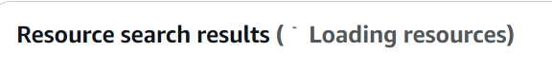
- Record the quantity displayed at the top of the search results when it completes displaying a number value:
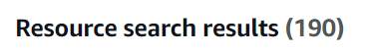
- Repeat steps in all accounts in scope for the assessment
- Calculate total resources from all recorded quantities

